Section 3 (JavaScript Assignments)

1. Create a new branch ‘js-assignments’.

2. Switch to ‘js-assignments’ branch.

3. Copy all JavaScript assignments inside ‘Assignments’ folder.

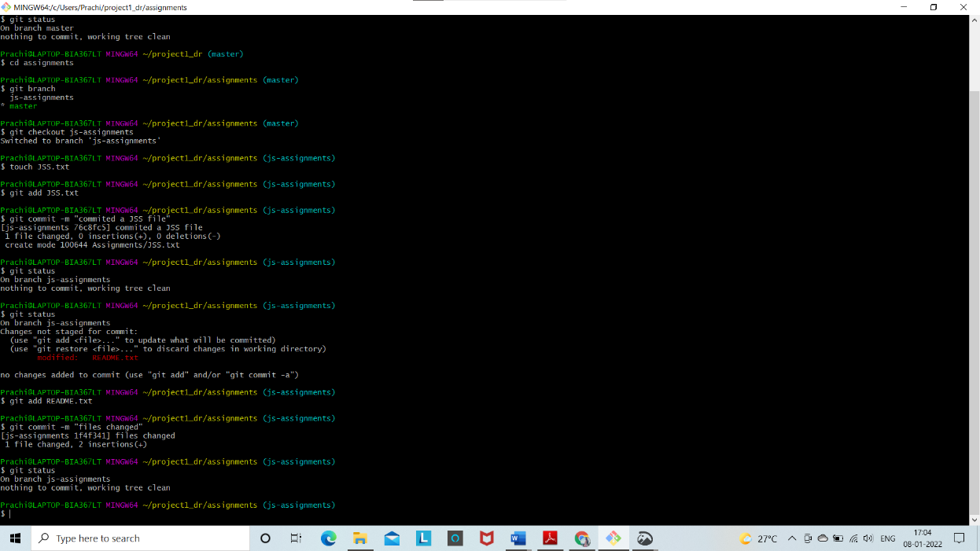4. Commit JavaScript assignments into ‘js-assignments’ branch.

5. Make minor changes into README.txt file on line 1 belonging to ‘js-assignments’ branch.

6. Commit those changed files.

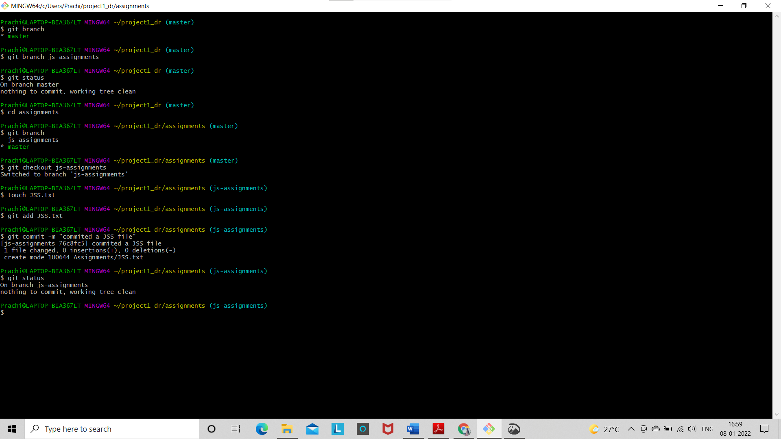

7. Switch to master branch.

8. Make minor changes into README.txt file on line 1 & commit those changes into master.

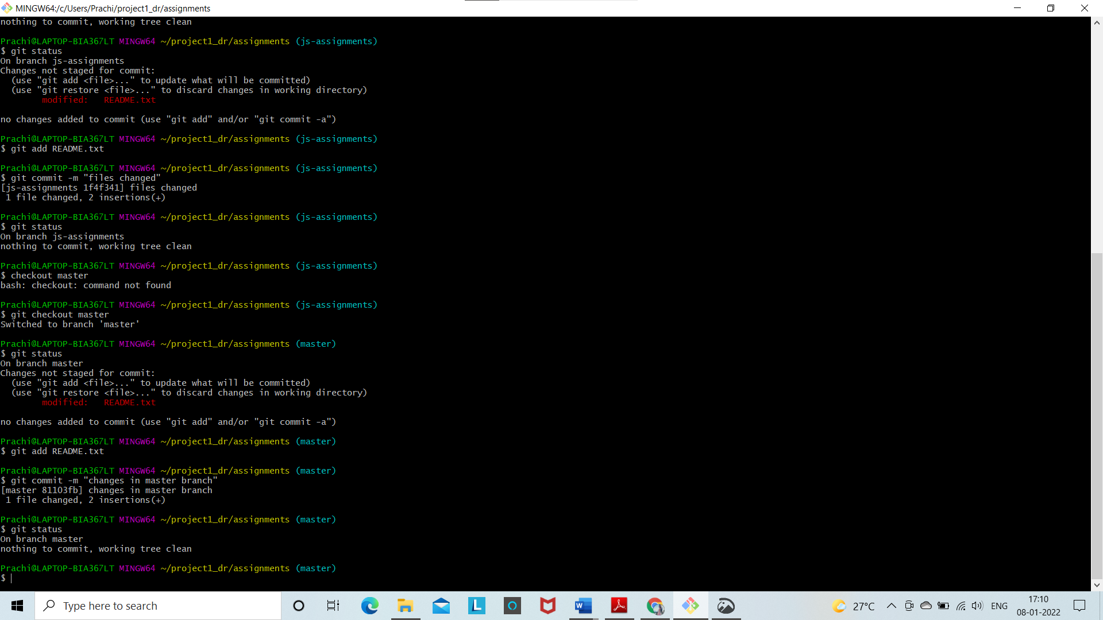

9. Again switch to ‘js-assignments’ branch.

10. Make minor changes into few files belonging to ‘js-assignments’ branch.

11. Commit those changes.

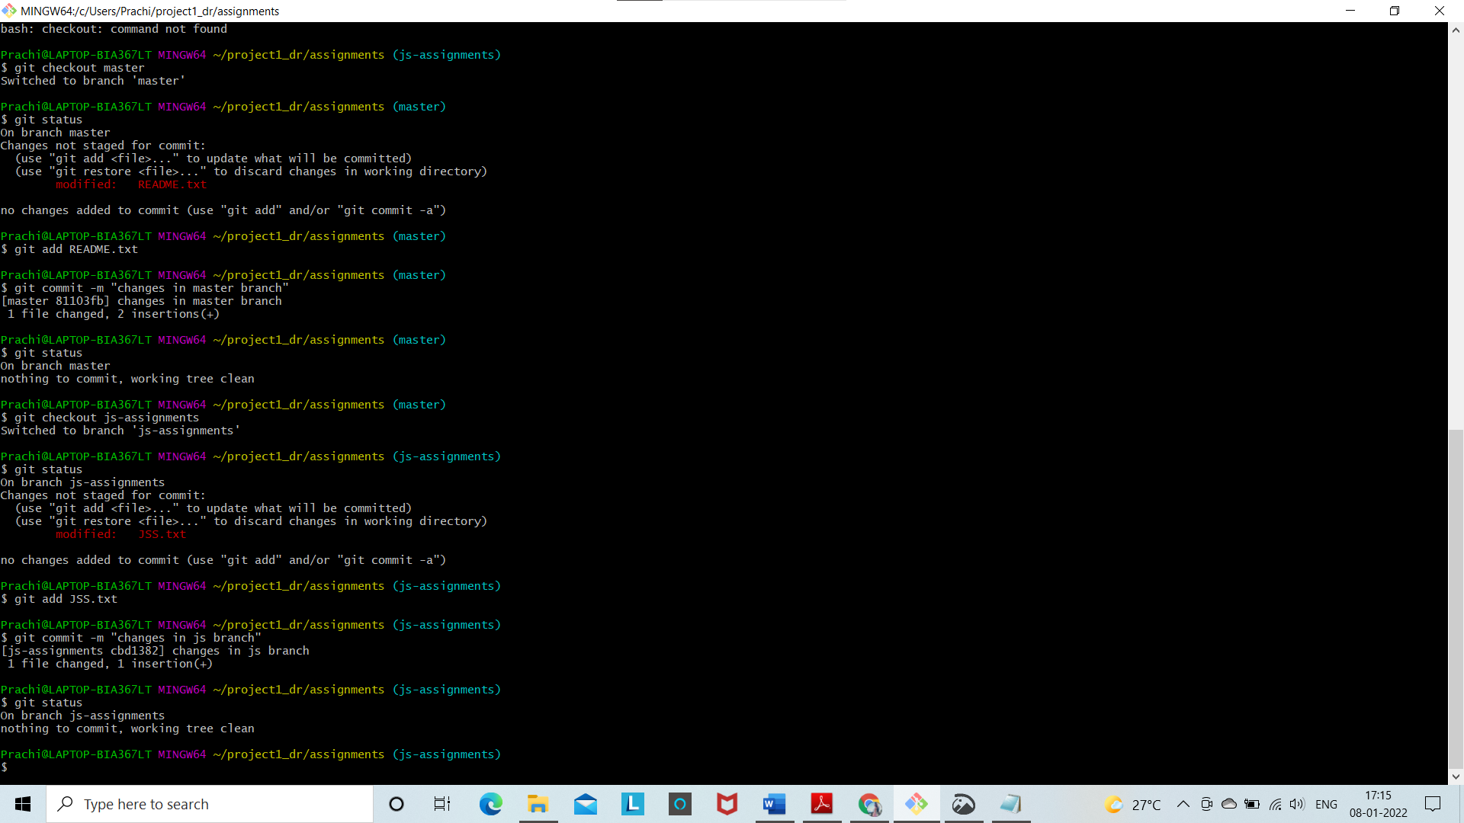

12. Switch to master.

13. Merge ‘js-assignments’ branch into master. Confirm all JavaScript assignments are shown in master.

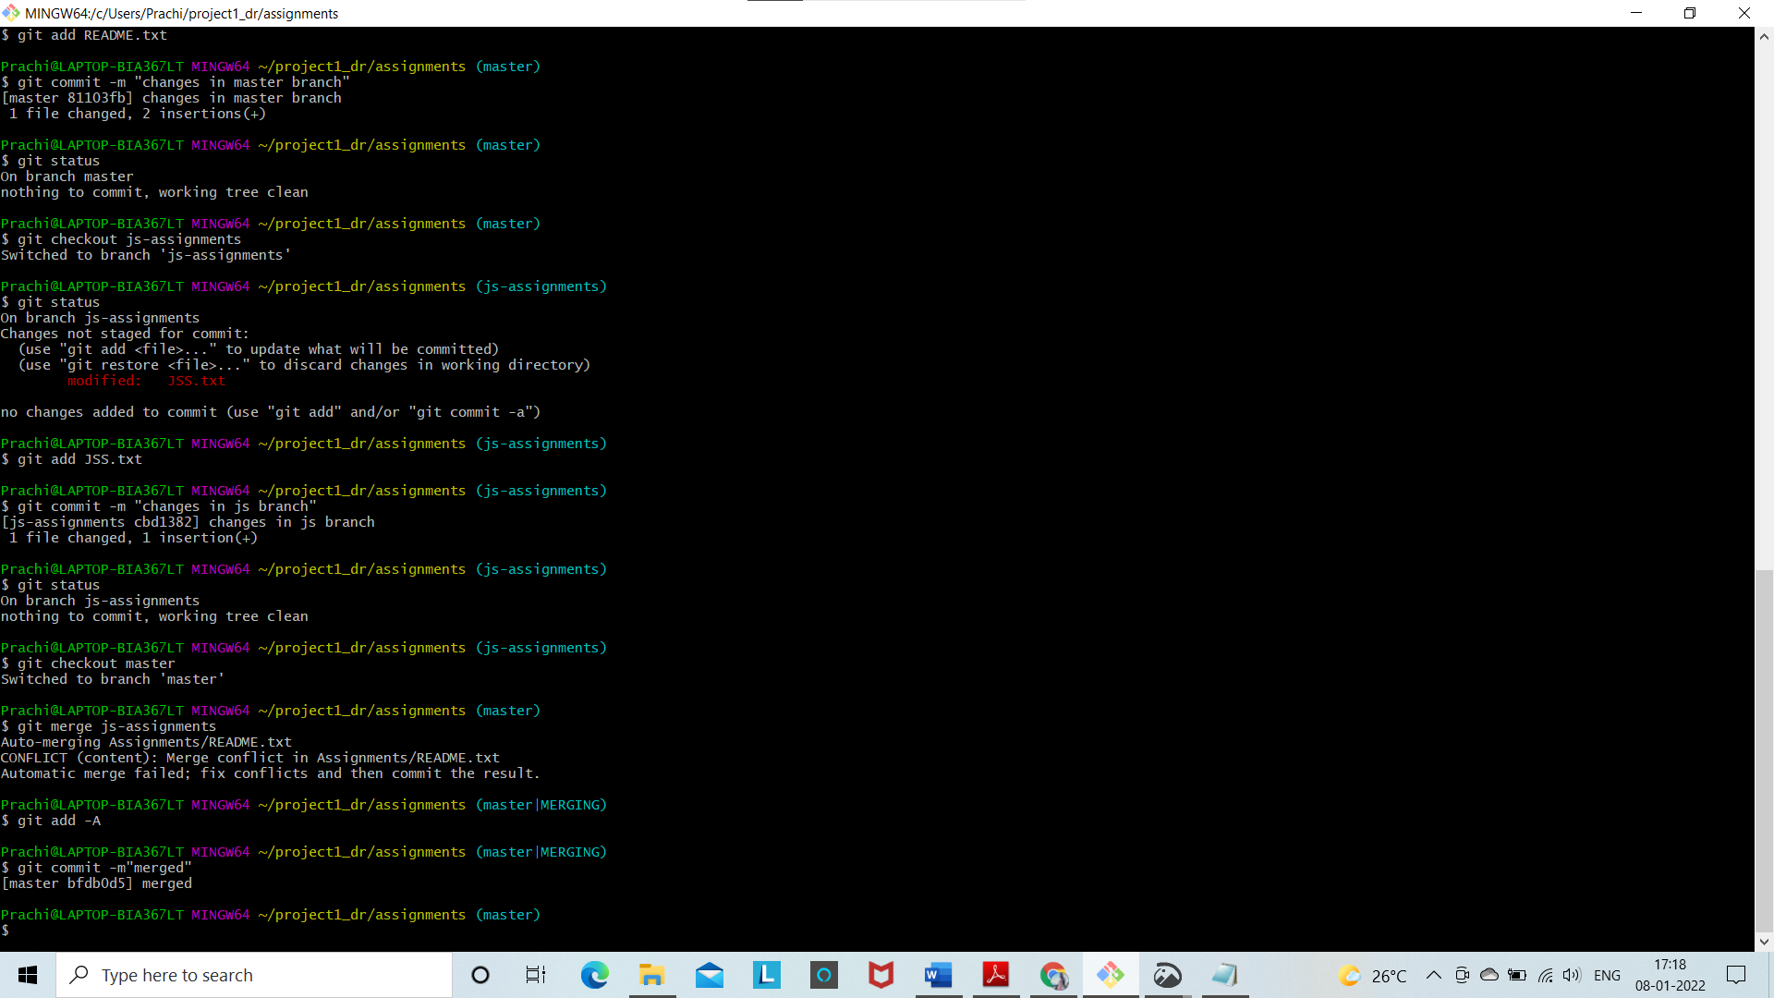

14. Finally delete the ‘js-assignments’ branch.

